Change language to “Beginning Student With List Abbreviations”

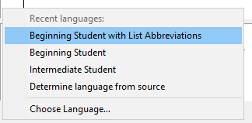 -> 

Let you write lists more compactly:



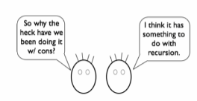

Running shows the values of list (even with using cons) using list notation

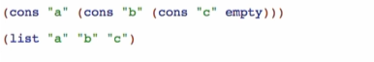

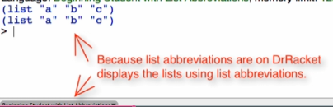

list

* Primitive for constructing lists
* (list <elements>)

Some differences of using cons and list as primitives



cons add in-front of the list

 -> 

- cons is like spreading the values of list

list add the elements as the list itself

 -> 

- list does not spread a value if it is a list

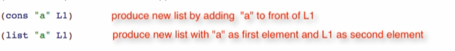

append

* Consumes 2 list and produce a single list (spread values)



 -> 